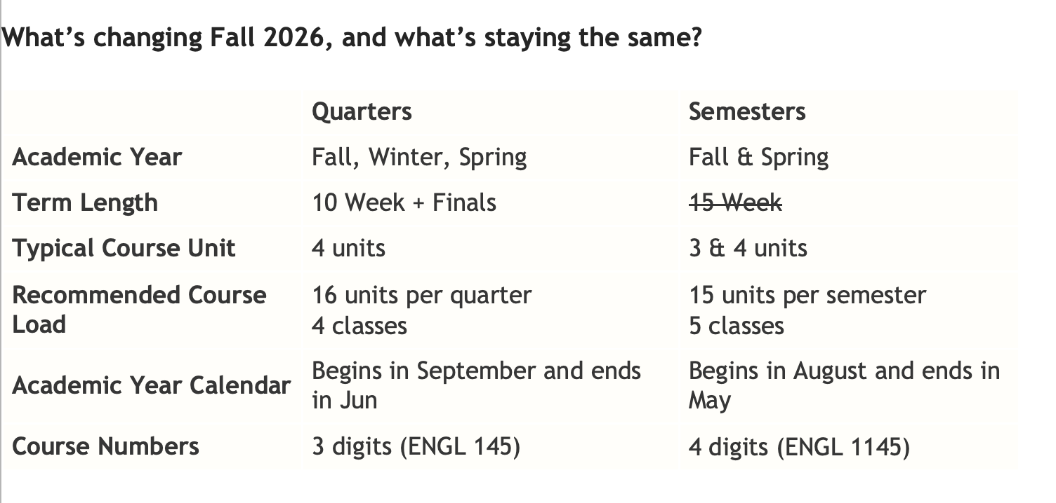*(waiting for the calendar to be confirmed to update term length under semesters)*

<p><strong>What’s changing Fall 2026, and what’s staying the same?</strong></p>

<table border="1" cellpadding="1" cellspacing="1">

<tbody>

<tr>

<td>&nbsp;</td>

<td><strong>Quarters</strong></td>

<td><strong>Semesters</strong></td>

</tr>

<tr>

<td><strong>Academic Year</strong></td>

<td>Fall, Winter, Spring</td>

<td>Fall &amp; Spring</td>

</tr>

<tr>

<td><strong>Term Length</strong></td>

<td>10 Week + Finals</td>

<td><s>15 Week</s></td>

</tr>

<tr>

<td><strong>Typical Course&nbsp;Unit</strong></td>

<td>4 units</td>

<td>3 &amp;&nbsp;4 units</td>

</tr>

<tr>

<td><strong>Recommended Course&nbsp;Load</strong></td>

<td>

<p>16 units per quarter</p>

<p>4 classes</p>

</td>

<td>

<p>15 units per semester</p>

<p>5&nbsp;classes</p>

</td>

</tr>

<tr>

<td><strong>Academic Year Calendar</strong></td>

<td>Begins in September and ends in Jun</td>

<td>Begins in August and ends in May</td>

</tr>

<tr>

<td><strong>Course Numbers</strong></td>

<td>3 digits (ENGL 145)</td>

<td>

<p>4 digits (ENGL 1145)</p>

</td>

</tr>

</tbody>

</table>